# Lab: Conditional Statements Advanced

Problems for in-class and homework exercises for the course ["Programming Basics" @ SoftUni](https://softuni.org/).

Test your solutions in the **Judge** system: <https://judge.softuni.org/Contests/3491/Conditional-Statements-Advanced-Lab-PS>

## Day of Week

Write a function that receives **an integer number** and prints the corresponding **day of the week** (in English), in the range [1...7] or prints "**Error**" in case of invalid input.

### Sample Input and Output

|  |  |
| --- | --- |
| **Input** | **Output** |
| printDayOfWeek(1) | Monday |
| printDayOfWeek(2) | Tuesday |
| printDayOfWeek(3) | Wednesday |
| printDayOfWeek(4) | Thursday |
| printDayOfWeek(5) | Friday |
| printDayOfWeek(6) | Saturday |
| printDayOfWeek(7) | Sunday |
| printDayOfWeek(-1) | Error |

### Hints and Guidelines

1. Create a **new JavaScript file** in the existing folder and name it appropriately. It is recommended to name each script file as the name of the task whose solution it contains.





1. The content of the new file will open in the window on the right.

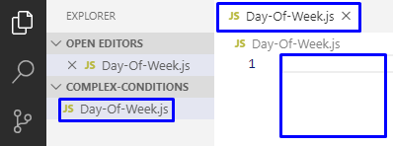

1. Convert the input from string to a number.
2. Print the day of the week, according to the input. If the number is invalid, print "**Error**".

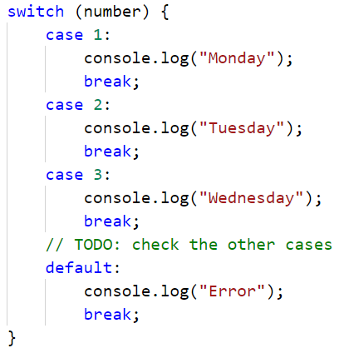

### Testing in the Judge System

Test the solution to this problem here: [https://judge.softuni.org/Contests/Compete/Index/3491#0](https://judge.softuni.org/Contests/Compete/Index/3491" \l "0      )

## Weekend or Working Day

Write a function that receives a day of the week (**string**) in English - entered by the user. If the day is a working day prints on the console - "**Working day**” if it is a holiday - "**Weekend**". If the input text is different from the day of the week it prints - "**Error**".

### Sample Input and Output

|  |  |
| --- | --- |
| **Input** | **Output** |
| isWorkingDay('Monday') | Working day |

|  |  |
| --- | --- |
| **Input** | **Output** |
| isWorkingDay('Sunday') | Weekend |

|  |  |
| --- | --- |
| **Input** | **Output** |
| isWorkingDay('April') | Error |

### Hints and Guidelines

1. Print **Working day** or **Weekend** according to the entered day, if the day is invalid print "**Error**":

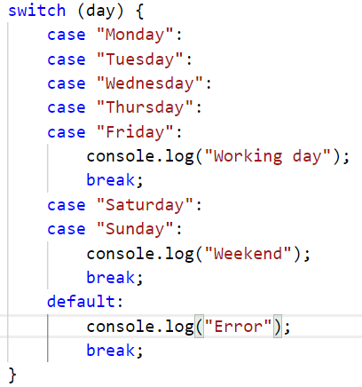

### Testing in the Judge System

Test the solution to this problem here: [https://judge.softuni.org/Contests/Compete/Index/3491#1](https://judge.softuni.org/Contests/Compete/Index/3491" \l "1      )

## Animal Type

Write a function that prints the type of an animal, according to the name entered by the user.

1. **dog -> mammal**
2. **crocodile, tortoise, snake -> reptile**
3. **others -> unknown**

### Sample Input and Output

|  |  |
| --- | --- |
| **Input** | **Output** |
| typeOfAnimal('dog') | mammal |
| typeOfAnimal('snake') | reptile |
| typeOfAnimal('test') | unknown |

### Hints and Guidelines

1. Check the animal type. If it’s invalid, print "**unknown**".

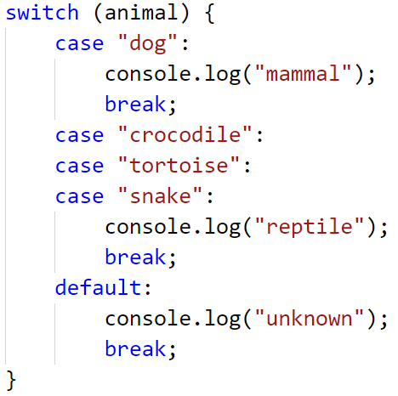

### Testing in the Judge System

Test the solution to this problem here: [https://judge.softuni.org/Contests/Compete/Index/3491#2](https://judge.softuni.org/Contests/Compete/Index/3491#2      )

## Personal Titles

Write a **function** that **receives an age** (a floating-point number) and a **gender** ('m' or 'f'), entered by the user, and prints a **personal title** among the following

* "Mr." – man (gender 'm') 16 years old or older
* "Master" – boy (gender 'm') under the age of 16
* "**Ms.**" – woman (gender 'f') 16 years old or older
* "**Miss**" – girl (gender 'f') under the age of 16

### Sample Input and Output

|  |  |  |  |  |  |  |  |  |  |  |
| --- | --- | --- | --- | --- | --- | --- | --- | --- | --- | --- |
| **Input** | **Output** |  | **Input** | **Output** |  | **Input** | **Output** |  | **Input** | **Output** |
| personalTitle(12,'f') | Miss | personalTitle(17,'m') | Mr. | personalTitle(25,'f') | Ms. | personalTitle(13.5,'m') | Master |

### Hints and Guidelines

1. Convert the age from a string to a numeric type.
2. Do a check for the gender, and if it returns **true**, do a check for the years. In the body of the age conditional statements, print the desired personal title.

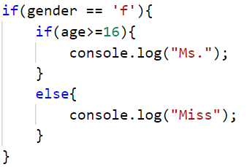 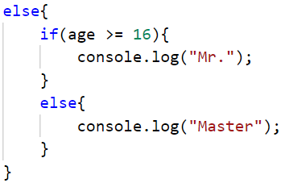

1. **Run** the program with [Ctrl+F5] and **test it** by calling the function at the bottom and giving it different input values.

### Testing in the Judge System

Test the solution to this problem here: [https://judge.softuni.org/Contests/Compete/Index/3491#3](https://judge.softuni.org/Contests/Compete/Index/3491#3      )

You must receive **100 points** (completely correct solution):



## Small Shop

Businessman opens **small shops** in **several cities** and sells at **different prices according to the city:**

|  |  |  |  |  |  |
| --- | --- | --- | --- | --- | --- |
| city / product | **coffee** | **water** | **beer** | **sweets** | **peanuts** |
| **London** | 0.50 | 0.80 | 1.20 | 1.45 | 1.60 |
| **Rome** | 0.40 | 0.70 | 1.15 | 1.30 | 1.50 |
| **Paris** | 0.45 | 0.70 | 1.10 | 1.35 | 1.55 |

Write a function that receives **3 arguments**: **product** (string), **city** (string), and **quantity** (number), and calculates and prints **how much** the corresponding quantity of the selected product costs in the specified city.

### Sample Input and Output

|  |  |  |  |  |  |  |  |  |  |  |  |  |  |
| --- | --- | --- | --- | --- | --- | --- | --- | --- | --- | --- | --- | --- | --- |
| **Input** | **Output** |  | **Input** | **Output** |  | **Input** | **Output** |  | **Input** | **Output** |  | **Input** | **Output** |
| solve('sweets', 'London', 2.23) | 3.2 | solve('peanuts', 'Rome', 1) | 1.5 | solve('beer', 'London', 2) | 2.4 | solve('water', 'Paris', 2) | 1.4 | solve('beer', 'London', 3) | 3.6 |

### Testing in the Judge System

Test the solution to this problem here: [https://judge.softuni.org/Contests/Compete/Index/3491#4](https://judge.softuni.org/Contests/Compete/Index/3491#4      )

## Number in Range

Write a function that checks if the number entered by the user is in the range [-100, 100] and if it’s different from 0 and outputs "**Yes**" if it meets the conditions, or "**No**" if it does not.

### Sample Input and Output

|  |  |  |  |  |  |  |  |
| --- | --- | --- | --- | --- | --- | --- | --- |
| **Input** | **Output** |  | **Input** | **Output** |  | **Input** | **Output** |
| solve(-25) | Yes | solve(0) | No | solve(25) | Yes |

### Testing in the Judge System

Test the solution to this problem here: [https://judge.softuni.org/Contests/Compete/Index/3491#5](https://judge.softuni.org/Contests/Compete/Index/3491#5      )

## Working Hours

Write a function that receives a time of the day (**an** **integer number**) and a day of the week (**text**) and checks if a company's office is open, with office hours **from 10 am to 6 pm**, **Monday** to **Saturday** inclusive.

### Sample Input and Output

|  |  |  |  |  |  |  |  |
| --- | --- | --- | --- | --- | --- | --- | --- |
| **Input** | **Output** |  | **Input** | **Output** |  | **Input** | **Output** |
| workingHours(11, "Monday") | open | workingHours(19, "Friday") | closed | workingHours(11, "Sunday") | closed |

### Testing in the Judge System

Test the solution to this problem here: [https://judge.softuni.org/Contests/Compete/Index/3491#6](https://judge.softuni.org/Contests/Compete/Index/3491#6      )

## Cinema Ticket

Write a function that receives a day of the week (text) and prints on the console the price of a movie ticket according to the day of the week:

|  |  |  |  |  |  |  |
| --- | --- | --- | --- | --- | --- | --- |
| **Monday** | **Tuesday** | **Wednesday** | **Thursday** | **Friday** | **Saturday** | **Sunday** |
| 12 | 12 | 14 | 14 | 12 | 16 | 16 |

### Sample Input and Output

|  |  |  |  |  |  |  |  |
| --- | --- | --- | --- | --- | --- | --- | --- |
| **Input** | **Output** |  | **Input** | **Output** |  | **Input** | **Output** |
| solve('Monday') | 12 | solve('Friday') | 12 | solve('Sunday') | 16 |

### Testing in the Judge System

Test the solution to this problem here: [https://judge.softuni.org/Contests/Compete/Index/3491#7](https://judge.softuni.org/Contests/Compete/Index/3491#7      )

## Fruit or Vegetable

Write a function that receives a **product name** as an argument and checks whether it is a **fruit** or a **vegetable.**

* Fruits "fruit" has the following possible values: **banana**, **apple**, **kiwi**, **cherry**, **lemon,** and **grapes**
* Vegetables "vegetable" has the following possible values: **tomato**, **cucumber**, **pepper,** and **carrot**
* Everything else is "unknown"

Output "fruit", "vegetable" or "unknown" according to the entered product.

### Sample Input and Output

|  |  |  |  |  |  |  |  |  |  |  |
| --- | --- | --- | --- | --- | --- | --- | --- | --- | --- | --- |
| **Input** | **Output** |  | **Input** | **Output** |  | **Input** | **Output** |  | **Input** | **Output** |
| solve('banana') | fruit | solve('apple') | fruit | solve('tomato') | vegetable | solve('water') | unknown |

### Testing in the Judge System

Test the solution to this problem here: [https://judge.softuni.org/Contests/Compete/Index/3491#8](https://judge.softuni.org/Contests/Compete/Index/3491#8      )

## 10. Invalid Number

Write a function that receives **an integer** argument, and prints "invalid" if the entered number **is not valid**. A given **number is valid** if it is in the range [**100...200**] or is **0**. If the number is valid print “**valid**”

### Sample Input and Output

|  |  |  |  |  |  |  |  |  |  |  |
| --- | --- | --- | --- | --- | --- | --- | --- | --- | --- | --- |
| **Input** | **Output** |  | **Input** | **Output** |  | **Input** | **Output** |  | **Input** | **Output** |
| solve(75) | invalid | solve(150) | valid | solve(220) | invalid | solve(199) | valid |

|  |  |  |  |  |  |  |  |  |  |  |
| --- | --- | --- | --- | --- | --- | --- | --- | --- | --- | --- |
| **Input** | **Output** |  | **Input** | **Output** |  | **Input** | **Output** |  | **Input** | **Output** |
| solve(-1) | invalid | solve(100) | valid | solve(200) | valid | solve(0) | valid |

### Testing in the Judge System

Test the solution to this problem here: [https://judge.softuni.org/Contests/Compete/Index/3491#9](https://judge.softuni.org/Contests/Compete/Index/3491#9      )

## 11. Fruit Shop

A fruit shop works on **weekdays** at the following **prices**:

|  |  |  |  |  |  |  |  |
| --- | --- | --- | --- | --- | --- | --- | --- |
| **fruit** | **banana** | **apple** | **orange** | **grapefruit** | **kiwi** | **pineapple** | **grapes** |
| **price** | 2.50 | 1.20 | 0.85 | 1.45 | 2.70 | 5.50 | 3.85 |

On **Saturdays** and **Sundays,** the shop sells at **higher prices**:

|  |  |  |  |  |  |  |  |
| --- | --- | --- | --- | --- | --- | --- | --- |
| **fruit** | **banana** | **apple** | **orange** | **grapefruit** | **kiwi** | **pineapple** | **grapes** |
| **price** | 2.70 | 1.25 | 0.90 | 1.60 | 3.00 | 5.60 | 4.20 |

Write a function that receives the following arguments: **fruit** ( banana / apple / orange / grapefruit / kiwi / pineapple / grapes), **day of the week** ( Monday / Tuesday / Wednesday / Thursday / Friday / Saturday / Sunday) and **quantity** (number) and calculates the **price**, according to the prices in the tables above. The result must be printed **rounded to 2 digits after the decimal point**. In case of invalid day of the week or fruit name, print "error".

### Sample Input and Output

|  |  |  |  |  |  |  |  |
| --- | --- | --- | --- | --- | --- | --- | --- |
| **Input** | **Output** |  | **Input** | **Output** |  | **Input** | **Output** |
| calculatePrice('apple', 'Tuesday', 2) | 2.40 | calculatePrice('orange', 'Sunday', 3) | 2.70 | calculatePrice('kiwi', 'Monday', 2.5) | 6.75 |

|  |  |  |  |  |
| --- | --- | --- | --- | --- |
| **Input** | **Output** |  | **Input** | **Output** |
| calculatePrice('grapes', 'Saturday', 0.5) | 2.10 | calculatePrice('tomato', 'Monday', 0.5) | error |

### Testing in the Judge System

Test the solution to this problem here: <https://judge.softuni.org/Contests/Compete/Index/3491#10>

## 12. Trade Commissions

A company gives the following trade **commissions** to its sellers according to the **city** in which they work and the volume of **sales:**

|  |  |  |  |  |
| --- | --- | --- | --- | --- |
| **City** | **0 ≤ s ≤ 500** | **500 < s ≤ 1 000** | **1 000 < s ≤ 10 000** | **s > 10 000** |
| London | 5% | 7% | 8% | 12% |
| Rome | 4.5% | 7.5% | 10% | 13% |
| Paris | 5.5% | 8% | 12% | 14.5% |

Write a **function** that receives a **city** name (string) and a **sales** volume (number) and calculates and outputs the trade **commission** according to the above table. Output the result formatted to **2 digits after the decimal point**. In case of **invalid** city or sales volume (a negative number) print "**error**".

### Sample Input and Output

|  |  |  |  |  |  |  |  |  |  |  |
| --- | --- | --- | --- | --- | --- | --- | --- | --- | --- | --- |
| **Input** | **Output** |  | **Input** | **Output** |  | **Input** | **Output** |  | **Input** | **Output** |
| solve('London', 1500) | 120.00 | solve('Paris', 499.99) | 27.50 | solve('Rome', 3874.50) | 387.45 | solve('Atlanta', -50) | error |

### Testing in the Judge System

Test the solution to this problem here: [https://judge.softuni.org/Contests/Compete/Index/3491#11](https://judge.softuni.org/Contests/Compete/Index/3491#11      )